Social Media Age Restrictions – What Secondary Students Need to Know
Stay Safe. Stay Smart. Know the Rules.
Minimum Age 13:




Minimum Age 16: Minimum Age 18:

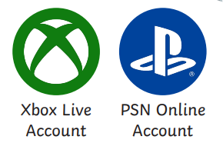

Why Age Restrictions Matter:
• Protects you from unsafe or inappropriate content
• Helps prevent contact from strangers
• Reduces risks of bullying or pressure online
• Keeps your personal information secure

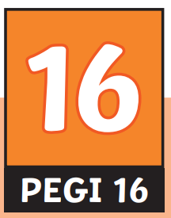
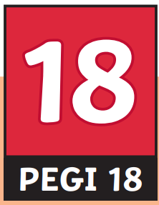
Gaming Age Ratings (PEGI):
• PEGI 3: Suitable for all
• PEGI 7: Mild fear or fantasy themes
• PEGI 12: Mild violence or bad language
• PEGI 16: Realistic violence or stronger language
• PEGI 18: Extreme violence or adult themes

Remember:
Just because “everyone else has it” does not mean it’s safe or allowed.
Always speak to a trusted adult if something online makes you uncomfortable.

